Unit 5 Geometry of Design

Preface
Geometric shapes are found everywhere. Take a moment to analyze products or objects you use every day. Geometric shapes and solids are the basis of these products. Engineers who have a strong understanding of these shapes, solids, and other geometric relationships can help designers develop and create solutions to a variety of problems. As designers progress through the design process and these design solutions are formalized, the level of accuracy and precision in the design specifications must increase. Conceptual sketches are converted to computer models and formal drawings, which include annotations describing the size and characteristics of the design features. A strong understanding of shapes and other geometric relationships is necessary to effectively and efficiently develop these computer and graphic representations.

Designers have used Computer Aided Design (CAD) programs for decades to refine ideas and generate images that manufacturers and other professionals can use to make profitable solutions to problems. The development of three-dimensional CAD solid modeling programs has resulted in significant increases in the quality of complex designs while drastically reducing the amount of time needed to produce those designs. Some engineers feel that the development of three-dimensional CAD solid modeling programs has made engineering more engaging and fun not to mention more accurate and precise.

Today’s software that employs parametric design functionality requires an understanding of geometric relationships, such as perpendicular, parallel, and tangent. Students will transfer their knowledge of geometric relationships to parametric modeling.

In this lesson students will apply the skills learned in prior units. They will learn how to calculate the area of two-dimensional shapes. Students will also learn how to calculate the surface area, volume, and weight of three-dimensional solids and the interaction of volume and weight to determine material density. Students will also improve their skill in the use of CAD modeling software to enhance their understanding of plane and solid geometry.

Unit 5 – Concepts & Objectives
Concepts | Objectives
An engineering design process involves a characteristic set of practices and steps. | • Complete a design project utilizing all steps of a design process, and find a solution that meets specific design requirements.
A problem and the requirements for a successful solution to the problem should be clearly communicated and justified. | • Define and justify a design problem, and express the concerns, needs, and desires of the primary stakeholders.
Brainstorming may take many forms and is used to generate a large number of innovative, creative ideas in a short time. | • Generate and document multiple ideas or solution paths to a problem through brainstorming.
Physical models are created to represent and evaluate possible solutions using prototyping technique(s) chosen based on the presentation and/or testing requirements of a potential solution. | • Construct a testable prototype of a problem solution.
Problem solutions are optimized through evaluation and reflection and should be clearly communicated. | • Identify limitations in the design process and the problem solution and recommend possible improvements or caveats.
The scientific method guides the testing and evaluation of prototypes of a problem solution. | • Analyze the performance of a design during testing and judge the solution as viable or non-viable with respect to meeting the design requirements.
Spreadsheet programs can be used to store, manipulate, represent, and analyze data. | • Use a spreadsheet program to store and manipulate raw data.  • Use a spreadsheet program to graph bi-variate data and determine an appropriate mathematical model using regression analysis.  • Use function tools within a spreadsheet program to calculate statistics for a set of data including mean, median, mode, quartiles, range, interquartile range, and standard deviation.  Note: Interquartile range is included for continuous improvement beyond 2012-2013.
An equation is a statement of equality between two quantities that can be used to describe real phenomenon and solve problems. | • Construct a scatter plot to display bi-variate data, investigate patterns of association, and represent the association with a mathematical model (linear equation) when appropriate.  Note: This aligns with the 2012-2013 PREVIEW curriculum.
Solving mathematical equations and inequalities involves a logical process of reasoning and can be accomplished using a variety of strategies and technological tools. | • Solve equations for unknown quantities by determining appropriate substitutions for variables and manipulating the equations.
Units and quantitative reasoning can guide mathematical manipulation and the solution of problems involving quantities. | • Convert quantities between units in the SI and the US Customary measurement systems.  • Convert between different units within the same measurement system including the SI and US Customary measurement systems.
Error is unavoidable when measuring a physical property and a measurement is characterized by the precision and accuracy of the measurement. | • Measure linear distances (including length, inside diameter, and hole depth) with accuracy using a scale, ruler, or dial caliper and report the measurement using an appropriate level of precision.  • Measure mass with accuracy using a scale and report the measurement using an appropriate level of precision.  • Measure volume with accuracy and report the measurement with an appropriate level of precision.
Two- and three-dimensional objects share visual relationships which allow interpretation of one perspective from the other. | • Identify three dimensional objects generated by rotations of two-dimensional shapes and vice-versa.
Physical properties of objects are used to describe and model objects and can be used to define design requirements, as a means to compare potential solutions to a problem, and as a tool to specify final solutions. | • Define the term “physical property” and identify the properties of length, volume, mass, density, surface area, centroid, principle axes, and center of gravity as physical properties.  • Solve volume problems using volume formulas for rectangular solids, cylinders, pyramids, cones, and spheres.  • Solve real world and mathematical problems involving area and surface area of two- and three-dimensional objects composed of triangles, quadrilaterals, polygons, cubes, right prisms, cylinders, and spheres.  • Calculate a physical property indirectly using available data or perform appropriate measurements to gather the necessary data (e.g., determine area or volume using linear measurements or determine density using mass and volume measurements).  • Use physical properties to solve design problems (e.g., design an object or structure to satisfy physical constraints or minimize cost).
Functions describe a special relationship between two sets of data and can be used to represent real world relationships and to solve problems. | • Use function notation, evaluate functions for inputs in their domains, and interpret statements that use function notation in terms of a context.  • Interpret the slope (rate of change) and the intercept (constant term) of a linear function in the context of data.  .
Geometric shapes and forms are described and differentiated by their characteristic features. | • Identify types of polygons including a square, rectangle, pentagon, hexagon, and octagon.  • Identify and differentiate geometric constructions and constraints such as horizontal lines, vertical lines, parallel lines, perpendicular lines, colinear points, tangent lines, tangent circles, and concentric circles.  • Identify types of angles including an acute angle, obtuse angle, straight angle, and right angle.
Computer aided drafting and design (CAD) software packages facilitate virtual modeling of parts and assemblies and the creation of technical drawings. They are used to efficiently and accurately detail parts and assemblies according to standard engineering practice. | • Create three-dimensional solid models of parts within CAD from sketches or dimensioned drawings using appropriate geometric and dimensional constraints.
Computer aided drafting and design (CAD) software packages allow virtual testing and analysis of designs using 3D models, assemblies, and animations. | • Assign a specific material (included in the software library) to a part and use the capabilities of the CAD software to determine the mass, volume, and surface area of an object for which a 3D solid model has been created.  • Assign a density value to a new material (not included in the software library) and apply the material to a 3D solid model within CAD software in order to determine the physical properties of the object.
In order to be an effective team member, one must demonstrate positive team behaviors and act according to accepted norms, contribute to group goals according to assigned roles, and use appropriate conflict resolution strategies. | • Demonstrate positive team behaviors and contribute to a positive team dynamic.

Essential Questions (Unit-Specific)
1. What are physical properties and why are they important to the design of a product?
2. What advantage does Computer Aided Design and Drafting (CAD) provide over traditional paper and pencil design?
3. How does the material chosen for a product impact the design of the product?

Essential Questions (Course-Wide)
1. How does the design process promote the development of good solutions to technical problems?
2. How can an engineer or technical professional effectively communicate ideas and solutions in a global community?
3. How do inventors and innovators impact and shape society?

Day-by-Day Plans
Time: 15 days

Days 1-5 | - The teacher will present Objectives, Concepts, Key Terms, Essential Questions, and provide a lesson overview.  - The teacher will distribute Activity 5.5 CAD Model Features.  - Students will work on Activity 5.5 CAD Model Features.
Days 6-15 | - The teacher will introduce and distribute Project 8.1b Model Arbor Press  - Students will work on Project 8.1b Model Arbor Press.  - Essential Question: What advantage does Computer Aided Design and Drafting (CAD) provide over traditional paper and pencil design?
Day 15 | - The teacher will distribute Activity 5.7 Instant Challenge: Choremaster.  - The students will complete Activity 5.7: Instant Challenge: Choremaster.

Standards and PLTW Concept and Objective Overviews
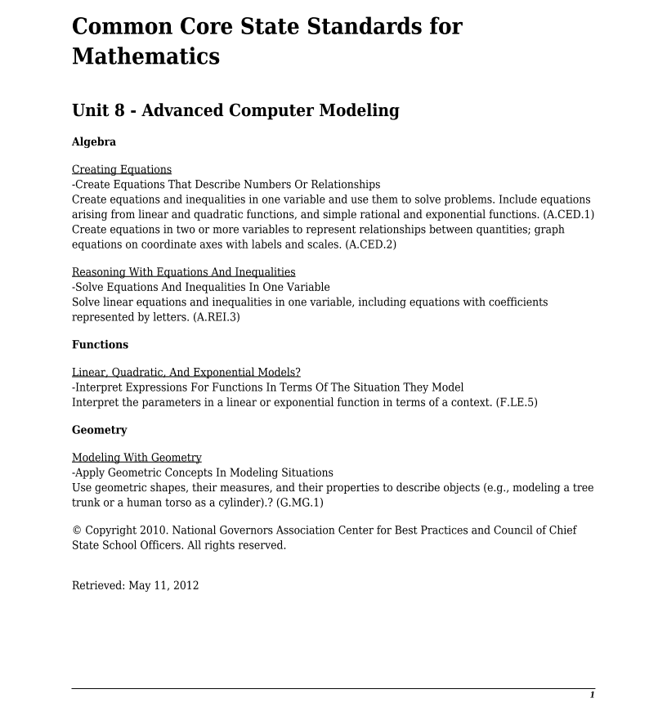
National Science Education Standards addressed in unit.
Unifying Concepts and Processes: As a result of activities in grades K-12, all students should develop understanding and abilities aligned with the following concepts and processes.
• Systems, order, and organization
• Evidence, models, and explanation
• Form and function

Science As Inquiry Standard A: As a result of activities in grades 9-12, all students should develop
• Abilities necessary to do scientific inquiry
• Understanding about scientific inquiry

Physical Science Standard B: As a result of activities in grades 9-12, all students should develop an understanding of
• Structure and properties of matter
• Motions and forces

Science and Technology Standard E: As a result of activities in grades 9-12, all students should develop
• Abilities of technological design
• Understandings about science and technology

Standards for English Language Arts addressed in unit.
Standard 4 | Students adjust their use of spoken, written, and visual language (e.g. conventions, style, vocabulary) to communicate effectively with a variety of audiences and for different purposes.
Standard 5 | Students employ a wide range of strategies as they write and use different writing process elements appropriately to communicate with different audiences and for a variety of purposes.
Standard 6 | Students apply knowledge of language structure, language conventions (e.g. spelling and punctuation), media techniques, figurative language, and genre to create, critique, and discuss print and non-print texts.

Standards for Technological Literacy addressed in unit.
Standard 2: Students will develop an understanding of the core concepts of technology.
BM AA: | Requirements involve the identification of the criteria and constraints of a product or system and the determination of how they affect the final design and development.
BM BB: | Optimization is an on going process or methodology of designing or making a product and is dependent on criteria and constraints.
BM CC: | New technologies create new processes.
Standard 8: Students will develop an understanding of the attributes of design.
BM H: | The design process includes defining a problem, brainstorming, researching and generating ideas, identifying criteria and specifying constraints, exploring possibilities, selecting an approach, developing a design proposal, making a model or prototype, testing and evaluating the design using specifications, refining the design, creating or making it, and communicating processes and results.
BM I: | Design problems are seldom presented in a clearly defined form.
BM J: | The design needs to be continually checked and critiqued, and the ideas of the design must be redefined and improved.
BM K: | Requirements of a design, such as criteria, constraints, and efficiency, sometimes compete with each other.
Standard 9: Students will develop an understanding of engineering design.
BM I: | Established design principles are used to evaluate existing designs, to collect data, and to guide the design process.
BM J: | Engineering design is influenced by personal characteristics, such as creativity, resourcefulness, and the ability to visualize and think abstractly.
BM K: | A prototype is a working model used to test a design concept by making actual observations and necessary adjustments.
BM L: | The process of engineering design takes into account a number of factors.
Standard 11: Students will develop abilities to apply the design process.
BM M: | Identify the design problem to solve and decide whether or not to address it.
BM N: | Identify criteria and constraints and determine how these will affect the design process.
BM O: | Refine a design by using prototypes and modeling to ensure quality, efficiency, and productivity of the final product.
BM P: | Evaluate the design solution using conceptual, physical, and mathematical models at various intervals of the design process in order to check for proper design and to note areas where improvements are needed.
BM Q: | Develop and produce a product or system using a design process.
BM R: | Evaluate final solutions and communicate observation, processes, and results of the entire design process, using verbal, graphic, quantitative, virtual, and written means, in addition to three-dimensional models.
Standard 12: Students will develop the abilities to use and maintain technological products and systems.
BM L: | Document processes and procedures and communicate them to different audiences using appropriate oral and written techniques.
BM P: | Use computers and calculators to access, retrieve, organize and process, maintain, interpret, and evaluate data and information in order to communicate.
Standard 16: Students will develop an understanding of and be able to select and use energy and power technologies.
BM J: | Energy cannot be created or destroyed; however, it can be converted from one form to another.
BM N: | Power systems must have a source of energy, a process, and loads.
Standard 17: Students will develop an understanding of and be able to select and use information and communication technologies.
BM L: | Information and communication technologies include the inputs, processes, and outputs associated with sending and receiving information.
BM M: | Information and communication systems allow information to be transferred from human to human, human to machine, machine to human, and machine to machine.
BM N: | Information and communication systems can be used to inform, persuade, entertain, control, manage, and educate.
BM P: | There are many ways to communicate information, such as graphic and electronic means.
BM Q: | Technological knowledge and processes are communicated using symbols, measurement, conventions, icons, graphic images, and languages that incorporate a variety of visual, auditory, and tactile stimuli.
Standard 18: Students will develop an understanding of and be able to select and use transportation technologies.
BM M: | The design of intelligent and non-intelligent transportation systems depends on many processes and innovative techniques.

